**Guided Capstone Project Report**

**Problem statement:**

How can operating costs be cut while selecting a better value for ticket prices to increase revenue for the resort by 20% over one year?

**Data Preparation and Analysis**

We began by cleaning and preparing the dataset, which involved addressing missing values and removing irrelevant columns. Out of 27 columns, 13 contained null values. We dropped the “fastEight” column due to its lack of useful information and excluded rows with no price data (approximately 14% of the dataset). Additionally, we removed an outlier record for Pine Knob Ski Resort due to an unrealistic value in the "yearsOpen" column.

To streamline the data, we focused on weekend prices, which had fewer missing values and were highly correlated with weekday prices. We created a new dataframe, "state_summary," containing state-wide summary statistics and information on the population and area for the US states.

Our exploratory data analysis revealed strong positive correlations between ticket prices and several features, including vertical drop, fastQuads, runs, and total chairs. These insights informed our model development and subsequent recommendations.

**Model Development**

We employed a linear regression model and a RandomForestRegressor for prediction. The RandomForestRegressor outperformed the linear regression model, with a mean absolute error (MAE) of 9.645 (standard deviation 1.353) on cross-validation, consistent with the test set performance (MAE of 9.538).

The RandomForestRegressor was chosen for further analysis due to its superior performance. Using this model, we estimated Big Mountain Resort's ideal ticket price at $95.87, compared to the current price of $81.00. This suggests an opportunity to increase the price, considering the model's expected MAE of $10.39.

**Scenario Analysis**

We evaluated four scenarios to identify the most viable options for increasing revenue or reducing costs:

1. **Closing Least-Used Runs:** Permanently closing up to 10 of the least-used runs would result in a stepped decline in ticket prices and revenue. Closing 3 to 5 runs would decrease revenue by $1.2 million, while closing 6 to 8 runs would decrease revenue by $2.2 million. This scenario is not recommended due to the significant negative impact on revenue.
2. **Increasing Vertical Drop:** Adding a run with a vertical drop of 150 feet and installing an additional chair lift would support a $1.99 increase in ticket price, potentially generating an additional $3.47 million in revenue.
3. **Increasing Vertical Drop with Snow Making:** Similar to scenario 2, but with 2 acres of additional snow-making coverage. This scenario did not show any significant difference in revenue compared to scenario 2.
4. **Extending Longest Run:** Increasing the longest run by 0.2 miles, requiring an additional 4 acres of snow-making coverage, showed no significant impact on revenue.

**Recommendations**

Based on our analysis, we recommend implementing Scenario 2: Increasing the Vertical Drop. This scenario offers a balanced approach to enhancing the resort's appeal while generating additional revenue. The estimated $1.99 increase in ticket price could lead to an additional $3.47 million in revenue, which can offset the costs of the new chair lift installation.

**Future Work**

To further refine our recommendations and ensure their feasibility, we suggest integrating detailed cost data for operating and maintaining key utilities, including the installation and operating costs for runs, FastQuads, chair lifts, trams, and snow-making per acre. This will enable a comprehensive cost-benefit analysis and help in identifying the most profitable strategies.

Our model provides a robust framework for continuous optimization of pricing strategies in a dynamic market. By making the model user-friendly and accessible to business analysts, Big Mountain Resort can continuously test various scenarios and adapt to changing market conditions.

**Conclusion**

Increasing the vertical drop and enhancing ticket pricing based on our model's insights offers a promising path for Big Mountain Resort to achieve its revenue goals. Implementing Scenario 2, with an estimated $1.99 increase in ticket price and additional $3.47 million in revenue, is our primary recommendation. Future work should focus on detailed cost analysis to ensure the long-term profitability and sustainability of the proposed changes.

**Figures and Graphs**

Below are the figures that support our analysis and recommendations:

Figure 1: PCA Plot of Ski States Summary

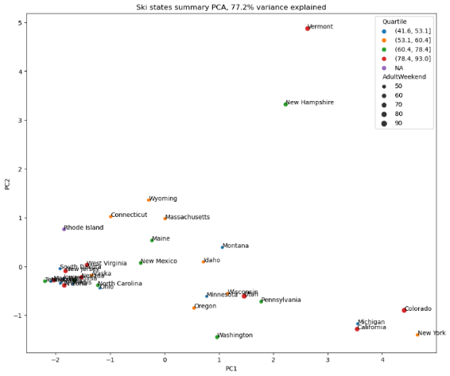

Figure 2: Scatterplot of Ticket Price vs. Vertical Drop

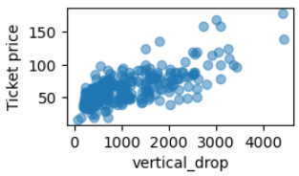

Figure 3: Model Performance Metrics for RandomForestRegressor

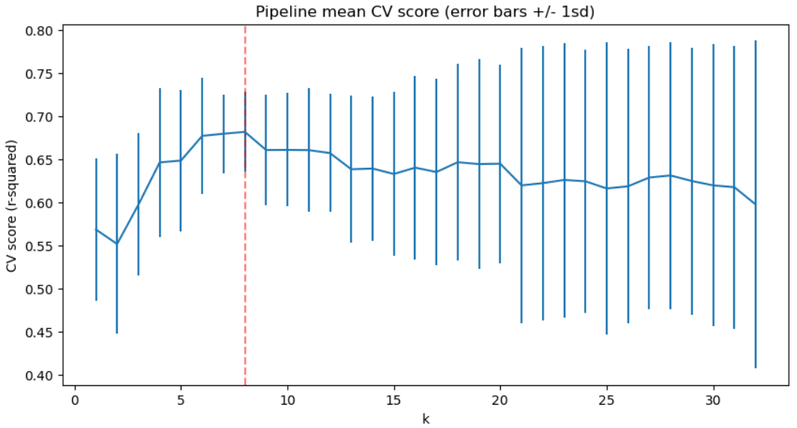

By leveraging these insights and strategic recommendations, Big Mountain Resort can achieve its goal of increasing revenue while maintaining operational efficiency and customer satisfaction.